Name ___________________________________________ Date ____________________

Momentum Change Investigation
Part 1: Use the graph below to show how the velocity of the cart would change from t=0 (when it starts traveling up the braking ramp) to the time at which it rolls all the way back down it.
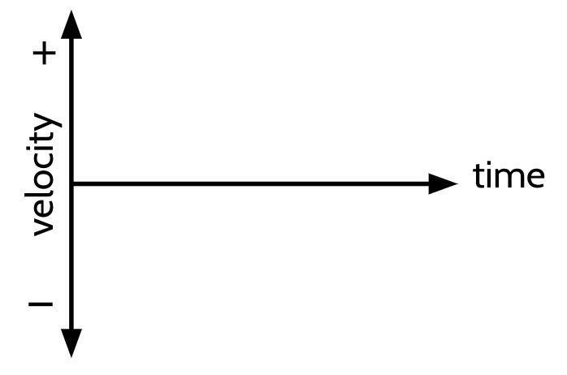
Part 2: (2 points) Make a quantitative prediction: How would doubling the amount of stopping force on the cart affect the time it takes to reach a velocity of zero when going up the second ramp? Assume the first “speeding up ramp” is the same each time. Use evidence from past experience AND previous lessons to justify your claim.

Part 3: Collecting data. Discuss with your group how many trials for each condition you plan to test in the 15 minutes available to collect data and which stopping ramp heights you plan to test (at least two of them!). You can have more than one person collect data for each trial. If you do, record all these related values collected in the corresponding row. Conduct as many trials as you consider necessary.
 | Possible Ramp Height Conditions for this Investigation
 | 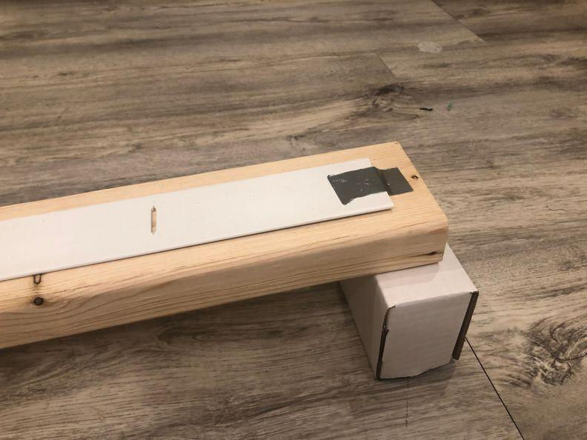  8.25 cm high brake ramp | 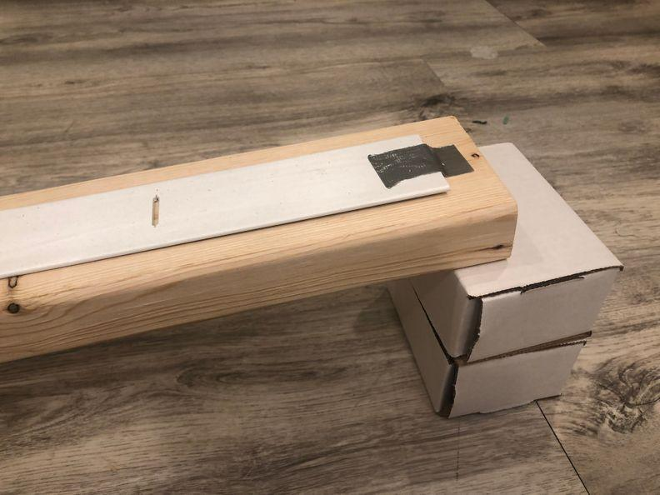  12 cm high brake ramp | 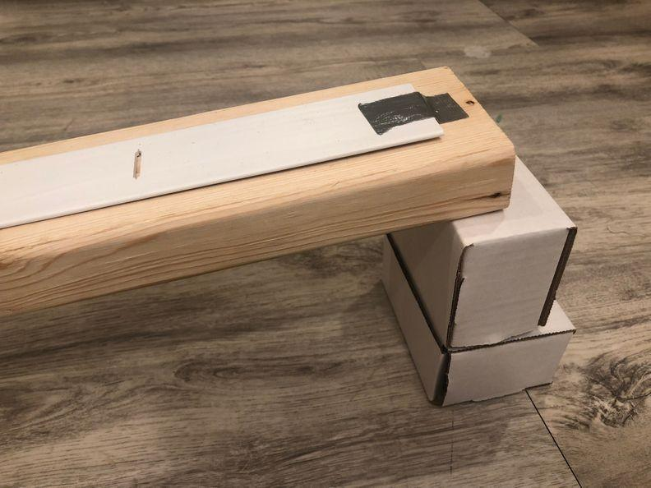  14.6 cm high brake ramp | 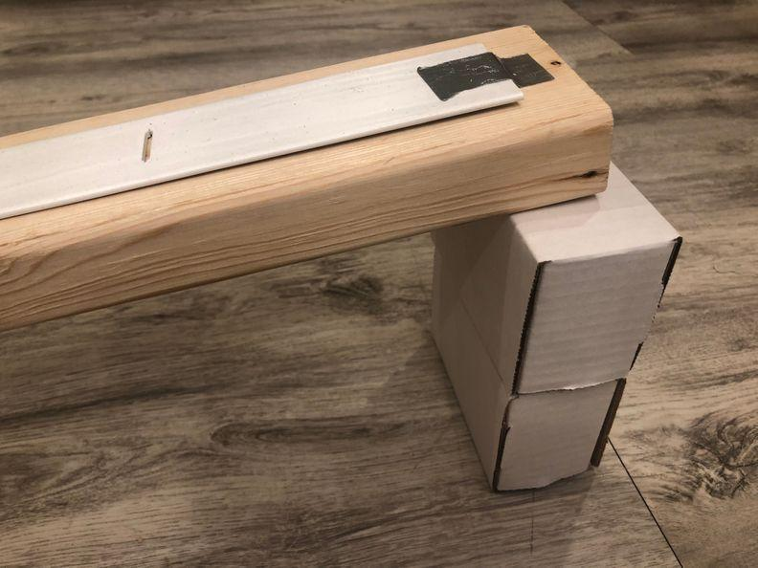  16.5 cm high brake ramp
Average net force acting on cart results on the braking ramp (from spring scale)
Average Net Force (in N)
Δt results from the braking ramp (time from vertex to where it stops)
Trial # | 8.25 cm high brake ramp  (seconds) | 12 cm high brake ramp  (seconds) | 14.6 cm high brake ramp  (seconds) | 16.5 cm high brake ramp  (seconds)
Average

Part 4: Determine the averages:
- What is the average Δt for each braking ramp height you tested with your group? (you should have at least two of these completed)
- 8.25 cm ramp: _______
- 12 cm ramp: _______
- 14.6 cm ramp: _______
- 16.5 cm ramp: _______

- What is the average Δt and Force for each braking ramp height tested in the class?
Δt: Force:
- 8.25 cm ramp: _______ ________
- 12 cm ramp: _______ ________
- 14.6 cm ramp: _______ ________
- 16.5 cm ramp: _______ ________

Part 5: Look back at your quantitative prediction that you made in Part 2.
- Do these experimental results support or refute the prediction from part 2 above? _____________________
- What specific observations, results, or evidence from the experiment supported or refuted the prediction? Describe trends/patterns in the data.
- Describe the physical principles that underlie these observations.

